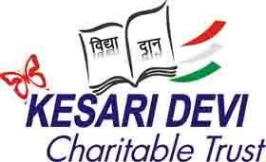

**KESARI DEVI CHARITABLE TRUST**

(Registration No:309/10, Varanasi, 15-09-2010)

B 31/25-22, Sankat Mochan Colony, Varanasi - 221005

#8419872155 www.trustkesari.org Email:trustkesari@gmail.com

Justice Abhinav Upadhya Prof. Ajit Narayan Tripathi Prof. Vibha Tripathi

Chairman Managing Trustee Jt. Managing Trustee

**A**

**ANNUAL REPORT 2023-24**

To, 08-May-2024

All our donors, partners and well wishers

Dear Friends,

The previous academic year witnessed an all-round progress of the Trust and its rural school. The number of students increased from 303 to 353. The school celebrated its Annual Day in December with a colorful cultural programme *Indraparni* presented by the students. The chief guest of the function was Dr. Ajay Pande of the Galaxy Hospital. Another important visitor to the school was Sri D.N.Bhargava, former Controller General of the Indian Bureaus of Mines. He is a 1953 batch Mining Graduate of IIT-BHU and the senior most donor of our Trust. Still very active at the age of 92, he travelled all the way from Mangalore to attend an academic seminar in BHU and to visit our school.

Along with regular academic activities there were several other fun filled students activities round the year. Fifteen of our students went on a two day trip to Lucknow, the city of Nawabs. A special attraction for them was the large Zoo there. Interestingly, it is called *Banarasi Bagh*. And the most interesting part of the trip was travelling by air. It was a once in a lifetime experience for the children. The trip was sponsored by our partners, Varanasi Round Table and the associated Ladies Circle. In addition, all the students of class VI to VIII visited the Parle-G biscuit factory in Ramnagar. They learnt how biscuits are made. They were offered biscuit packets along with other goodies. A group of our students went to the Delhi Public School, Varanasi to spend a day and to interact with students of that school. In return a group of DPS students came to our school for joint activities. Traffic authorities visited the school and explained the traffic rules to the students. Another function was a Bharat Natyam performance by a classical dancer. The last activity of the session was the farewell function for the passing out students of class VIII. It was a touching experience, both for the students and their teachers.

Our building partner, Varanasi Round Table completed and inaugurated a block of two new classrooms. The associated Ladies Circle presented furniture for the classrooms and some musical instruments to form the nucleus of a new music room. We plan to appoint a music teacher to organize the teaching of music to our students. Another supporter of the school, Rotary Club, Varanasi Central, presented bicycles to twenty of our girl students. Several senior members of the club were present at a function organized on the occasion.

In the earlier years we had received CSR support from two corporate bodies, Tata Trusts and Oppo Mobiles, India. In the session 2023-24 we received similar support from two other companies. The HDFC bank gave us a basic science lab, a smart classroom and several others Infrastructure facilities. The financial outlay was Rs. 20 Lakh. The project was executed by their implementing agency Ambuja Cement Foundation. The bank also gave scholarships to 50 needy students. The amount was Rs. 15,000/ per student and it was directly credited to the parents’ account. The total of scholarship amount was Rs. 7.5 Lakh. The second CSR support comes from PowerHF India Ltd. They gave us a grant of Rs. 5 Lakh for paying teachers’ salaries and other school expenses. The founder and CEO of the company is Sri Harish Jere, 86 batch graduate of IIT-BHU. Another company, Windlass Biotech, has agreed to give us a CSR grant of Rs. 5 Lakh per year for three years to implement a video-based value education programme for the students of class VI to VIII. The CEO of the company is Sri Hitesh Windlass. He is a 98 batch graduate of IIT-BHU.

To make quality education accessible to the economically weaker sections, the fee charged from the parents has been kept at a low level of Rs. 500/-per month. However, the operating expenses of the school is Rs. 1000/- per students per month. Raising donations to meet the difference between the two is a major challenge for us. We have two channels to receive individual donations for this purpose. One is our ‘Educate a Child (EAC)’ scheme. Under it we request donors to donate Rs. 6000/- per child per year or Rs. 500/- per month to support the education of one or more children. Some donors support as many as five children. We could raise Rs.3.21 Lakh under this scheme during the previous year. The other channel is contribution to our permanent Endowment Fund. This fund is invested in mutual funds whose monthly returns go towards meeting the operating expenses. We raised Rs. 6.76 Lakh during the previous year for this fund. The fund has grown up to the level of Rs. 50 Lakh. Our target is Rs. 100 Lakh. I urge you all to donate to the fund generously so that we can reach the target within a couple of years. We will then have a stable source for meeting the operating expenses and the school will become financially sustainable. You can transfer your contribution into our Axis bank S/B account in the name of Kesari Devi Charitable Trust, A/c no. 910010040238705, IFSC code UTIB0000856 .

Another welcome trend emerged last year. Prof. Sharad Gupta, instituted three scholarships in the name of his father, late Sri J.P. Gupta. The scholarships cover the entire cost of education for one year, i.e. school fee of Rs. 12,000/- plus cost of books and dress, Rs. 4500/-. It is awarded to the students securing highest marks in classes V, VI, VII. This year also two such scholarships have been afford by Sri Nirjhar Prakash and Sri Keerthi Kant. I invite you to join the move so that many more needy and meritorious students could be helped.

Our greatest challenge at present is to develop the school up to the level of a Higher Secondary School. We need a capital outlay of Rs. 4 Crore to add a second block to the existing school building, purchase additional land for sports ground, and to build up laboratories and other infrastructure facilities. We are looking for CSR support to raise this amount. I request you to please help me locate the right persons to contact and to seek CSR support for this second phase of development. In the end I thank all our donors, partners and well-wishers whose financial contributions and encouragement have helped us move forward towards our goal of providing quality education at an affordable cost to the economically deprived rural children.

A.N.Tripathi

Managing Trustee

Snap Shot:

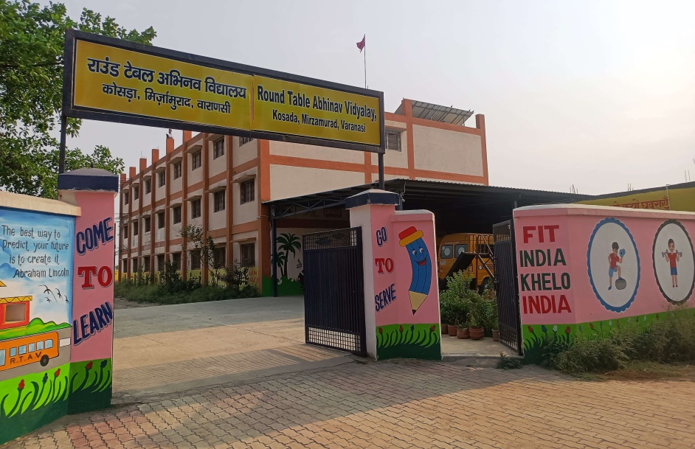 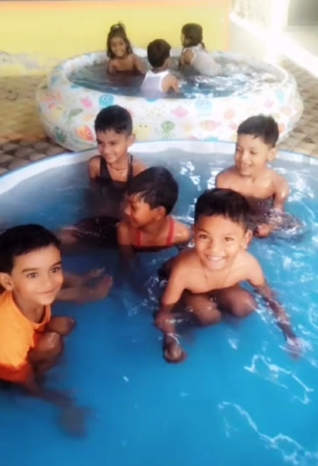 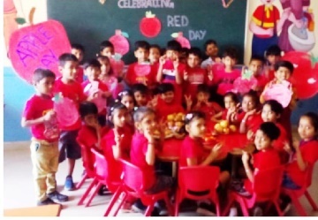 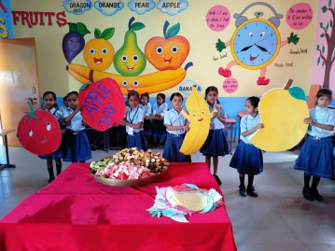 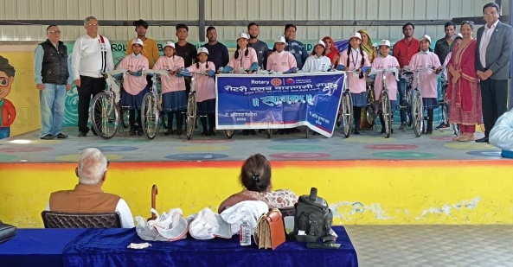

**Cycles for girl students -**

**Women empowerment**

**Red Day**

**Fruits for good health**

**Pool activity for Nursery**

**School at a glance**

**Flight of Fantasy**

**Focus & Balance**

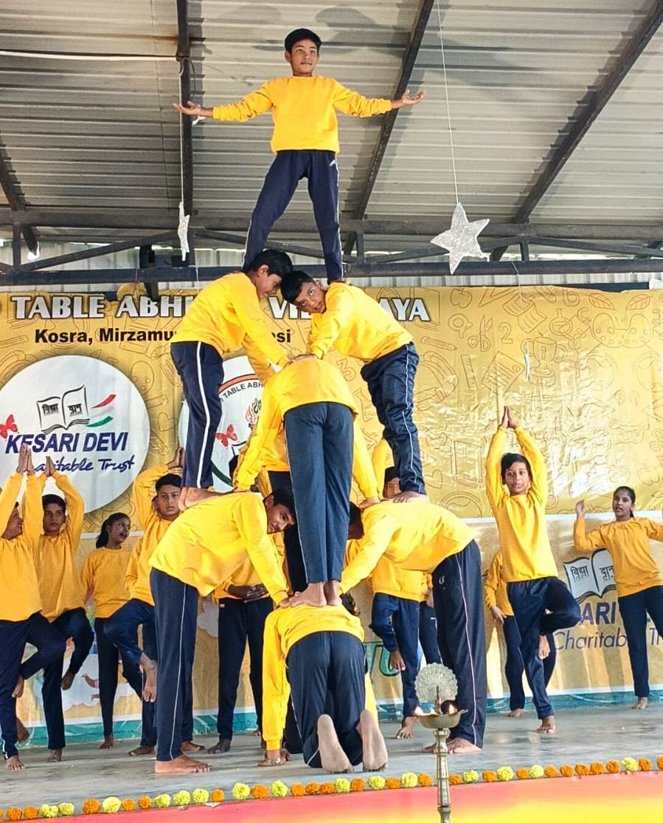 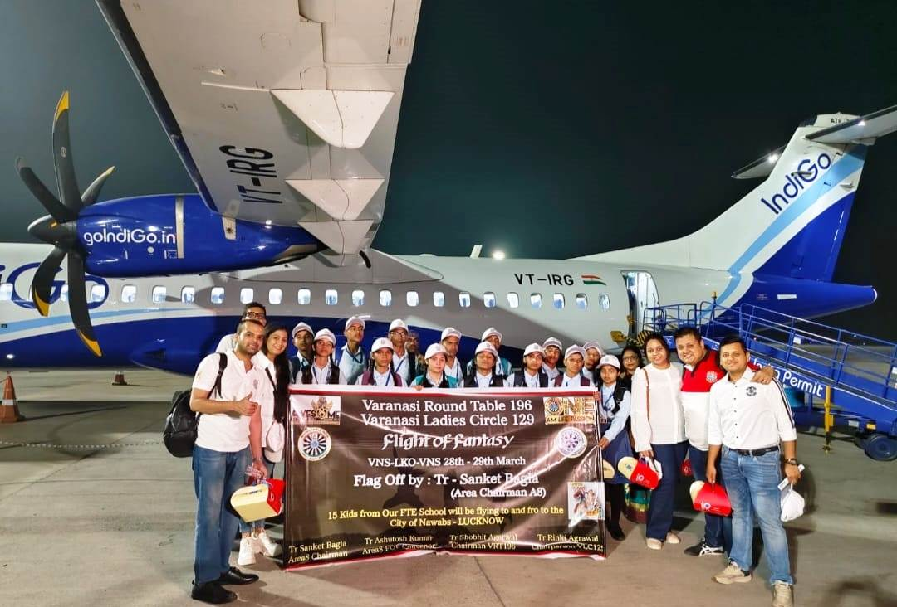

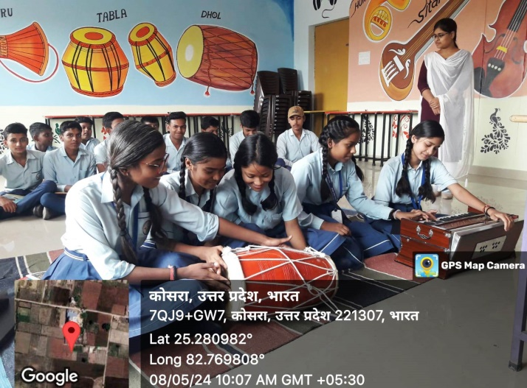 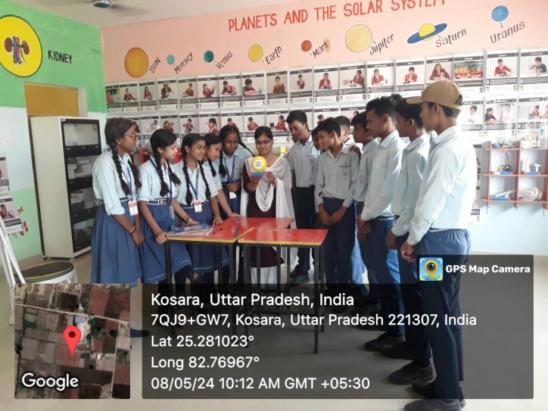

**Music Room**

**Science Lab**

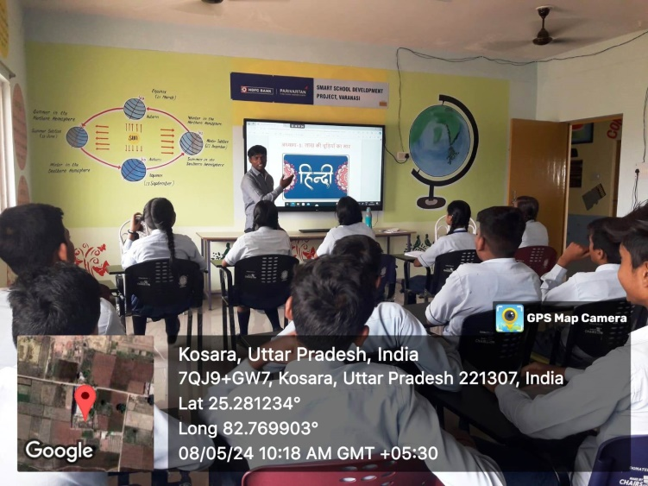 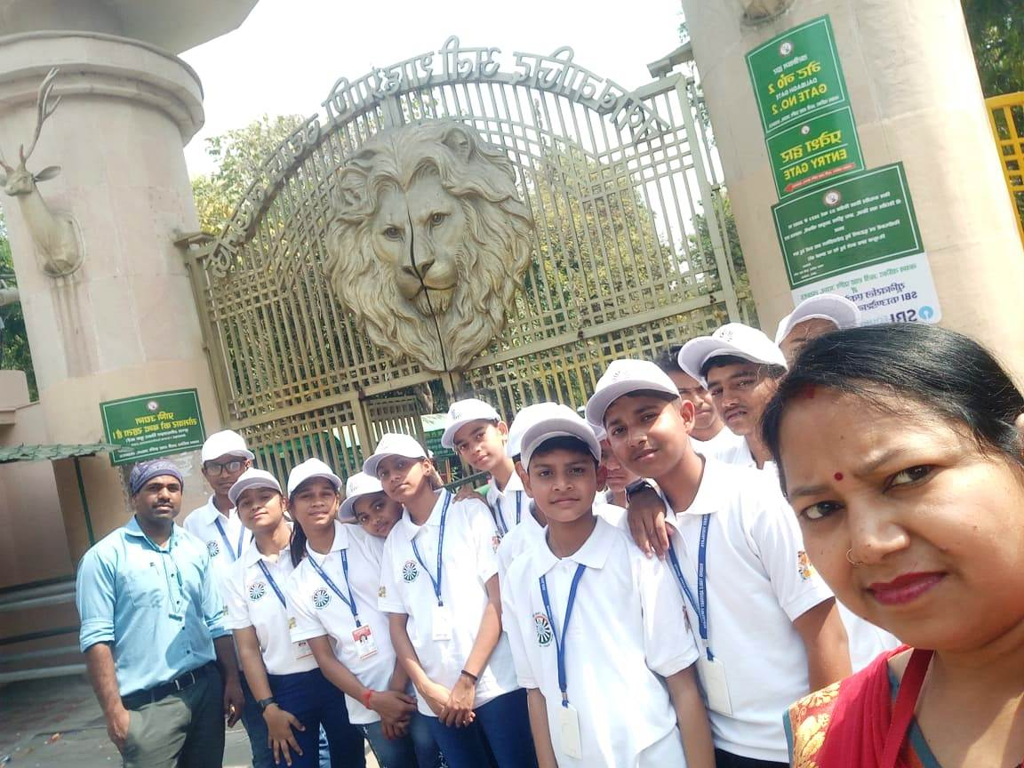

**Lucknow Zoo**

**Smart Classroom**

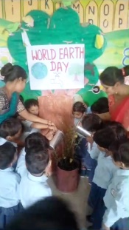 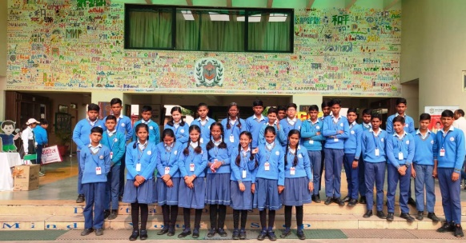 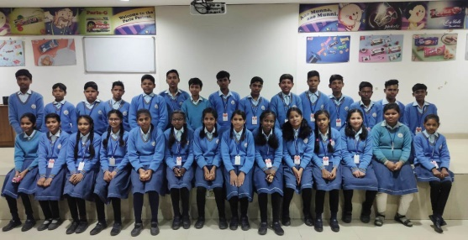

**Parle – G – Factory visit**

**DPS Varanasi visit**